***Dt : 26/8/2022***

***Execution flow of above program:***

***ClassFiles:***

***DemoBlock1.class***

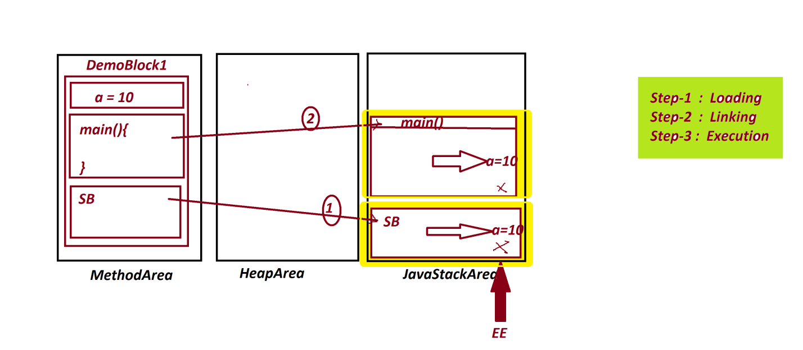

***=======================================================***

***Ex-Program : DemoBlock2.java***

***class BTest1 //SubClass***

***{***

***static int b;***

***static***

***{***

***System.out.println("====SubClass Static block====");***

***System.out.println("The value b:"+b);***

***}***

***}***

***class DemoBlock2 //MainClass***

***{***

***public static void main(String[] args)***

***{***

***BTest1.b=200;//Initializing Static Variable***

***//using SubClass for initialization***

***System.out.println("=====main()====");***

***System.out.println("The value b:"+BTest1.b);***

***}***

***}***

***o/p:***

***====SubClass Static block====***

***The value b:0***

***=====main()====***

***The value b:200***

***========================================================***

***Execution flow of above program:***

***ClassFiles:***

***BTest1.class***

***DemoBlock2.class(MainClass)***

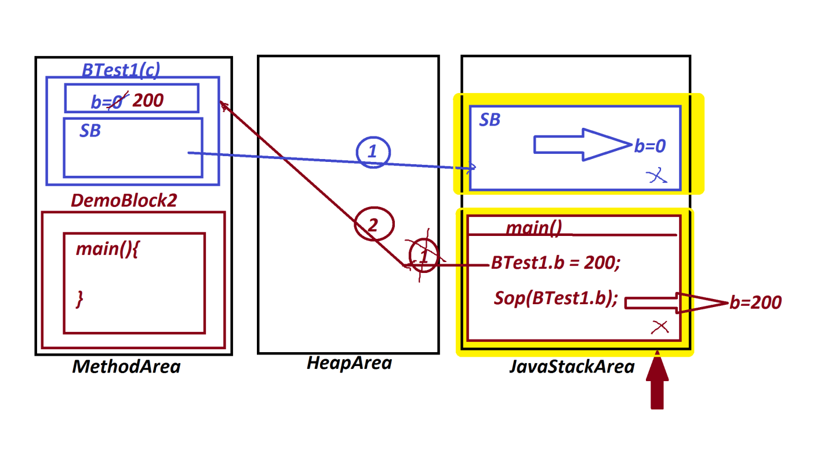

***======================================================***

***Note:***

***=>In realtime static blocks are used to hold DataBase***

***Connection code part of DAO(Data Access Object) layer in MVC***

***(Model View Controller)***

***======================================================***

***2.Non-Static blocks or Instance blocks:***

***=>The blocks which are declared without 'static' keyword are***

***known as Non-Static blocks or Instance blocks.***

***syntax:***

***{***

***//set-of-statements***

***}***

***behaviour:***

***=>These Instance blocks are executed while object creation***

***process.***

***=>These Instance blocks are executed for all the multiple***

***Object creations.***

***=>These Instance blocks can access both Instance Variables***

***and Static Variables.***

***Ex-program : DemoBlock3.java***

***class BTest2 //SubClass***

***{***

***int a=10;//Instance Variable memory in Object***

***static int b=20;//Static memory in Class***

***{***

***a++;***

***b++;***

***System.out.println("===SubClass Instance block===");***

***System.out.println("The value a:"+a);***

***System.out.println("The value b:"+b);***

***}***

***}***

***class DemoBlock3 //MainClass***

***{***

***public static void main(String[] args)***

***{***

***System.out.println("****ob1****");***

***BTest2 ob1 = new BTest2();***

***System.out.println("****ob2****");***

***BTest2 ob2 = new BTest2();***

***}***

***}***

***o/p:***

***\*\*\*\*ob1\*\*\*\****

***===SubClass Instance block===***

***The value a:11***

***The value b:21***

***\*\*\*\*ob2\*\*\*\****

***===SubClass Instance block===***

***The value a:11***

***The value b:22***

***=====================================================***

***Execution flow of above program:***

***ClassFiles:***

***BTest2.class***

***DemoBlock3.class(MainClass)***

